No structured clinical data was migrated from IMS into eCW. PDF versions of the patient progress note(s) and documents were migrated into eCW within the patients document folder. Migrated visit notes was completed for the time frames of 6/1/17- 9/20/20
Access PDF progress notes & documents from Pt Hub
- Use the patient look up to search and select the patient or click the HUB button on the patient’s progress note
- On the patient hub, select the patient docs icon
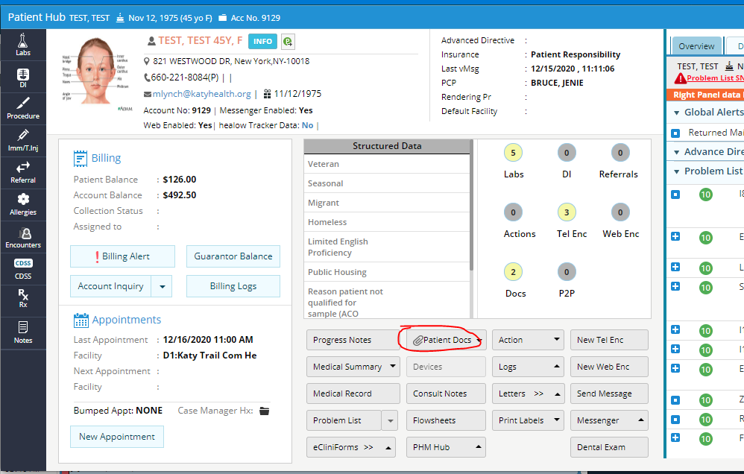
- The patient documents screen will open in a new window.
- Migrated information can be found in the Migrated_documents folder on the far left of the screen.
- Click on any document on the left to open a viewable version
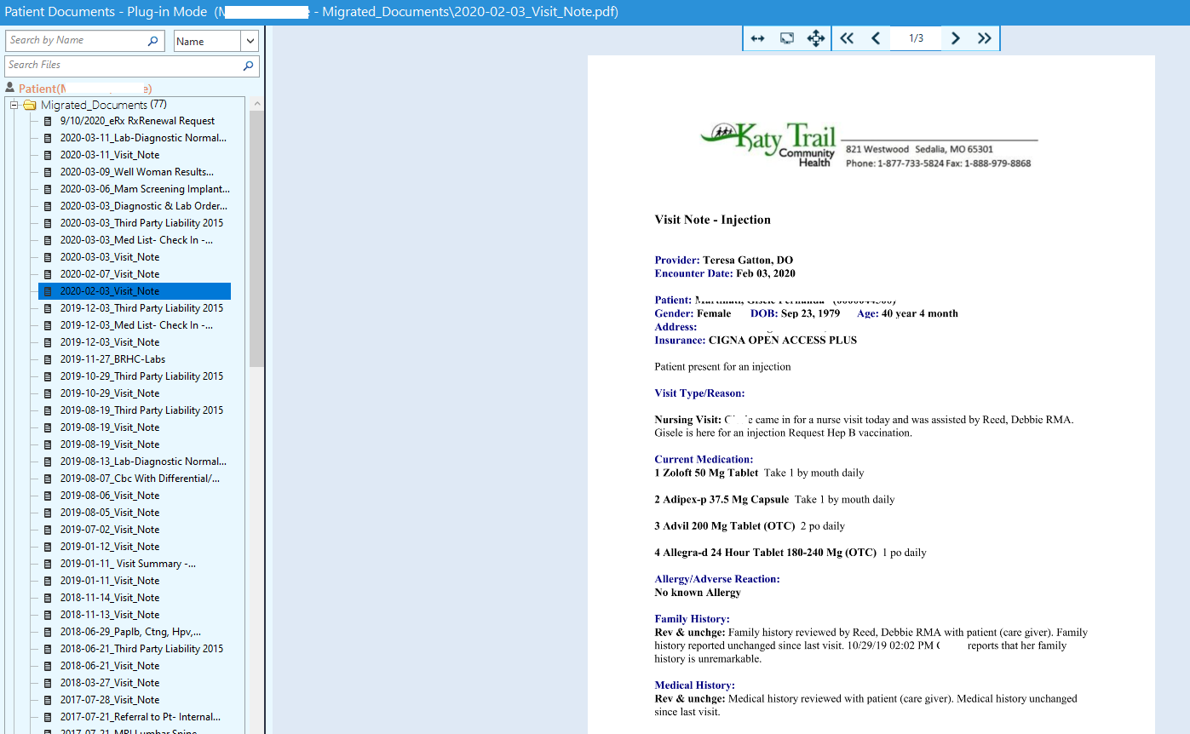

Note: Since information did not come over as structured clinical data, it is not viewable from the encounters. This will only show you past appt dates & times. To see the actual note, go to the patient documents tab.

