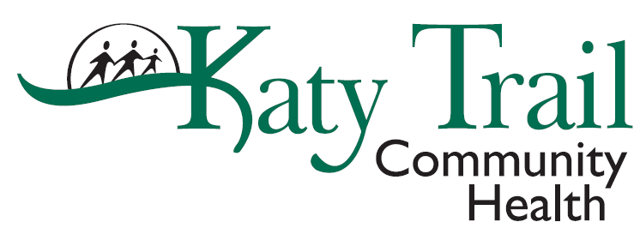

MEMORANDUM
To: All Employees
From: Tina Fisher, HR Director

Date: April 3, 2020
RE: Staff Retention
In times of uncertainty, we often feel fear the most. It can be a scary thing to not know what to expect and how to handle the changes that are being thrown at us on what seems like a daily basis. No one and no business is exempt from changes, however, we can communicate to you to clarify any concerns you may have.
Katy Trail Community Health is dedicated to keeping staff safe and working on staffing plans to reduce the risk exposure of COVID-19 to our staff. Risk exposure includes the proximity of working with patients, duration of exposure and availability of personal protection equipment. We have taken the following steps to reduce exposure:
- Our dental staff was triaged out of service as soon as possible. We have a dentist on call with a support staff in clinic that consists of a PSR, dental assistant and the dental assistant lead.
- Medical clinical staff have begun rotations as providers are working appointments through Zoom.
- Behavioral Health is conducting visits through Zoom.
With our visits significantly dropping, we will need to look at additional staff rotations and/or non-work days. Managers will be discussing staffing needs with you. We are committed to paying full wages for non-worked time through the month of April 2020. While we are paying wages for non-worked hours, an employee is considered “on call” and should be available to work when your manager or HR contacts you. If you are requesting not to work or deny a shift when called, you will be charged your paid time off earnings. The commitment to pay full wages will be re-evaluated monthly during this pandemic. We want to keep all of our staff safe and healthy, including financially.
If you have any questions regarding this staffing plan, please send them to Sue Borgmeyer at sborgmeyer@katyhealth.org to be addressed on our Monday Staff Zoom meeting.

