In the patient hub, click on account inquiry under billing:

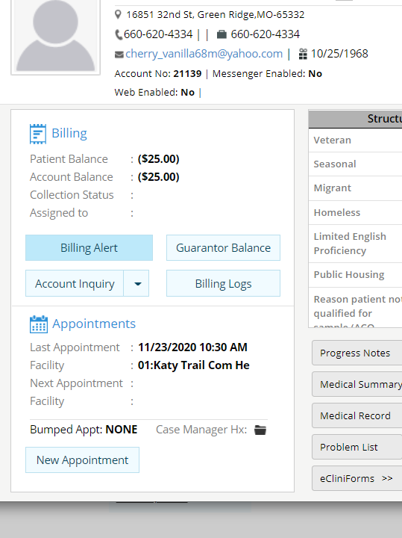
Click on patient payments at the bottom:
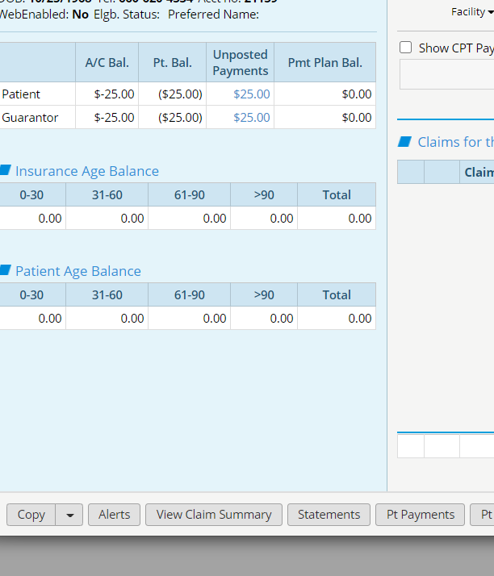

Click on the payment that needs to be changed. This will bring up the patient payment window. Click on the up arrow next to print receipt (publish to portal) and select unlock payment and ok
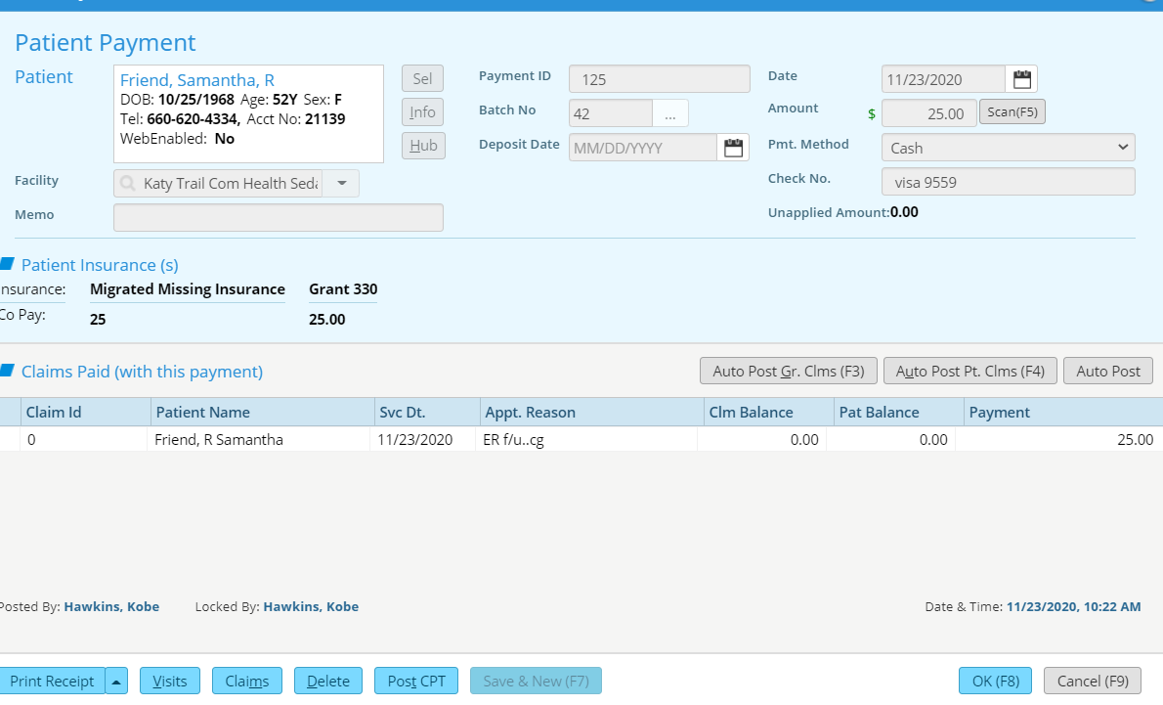
Click back on the payment and change payment method at top. Click Ok and ok.
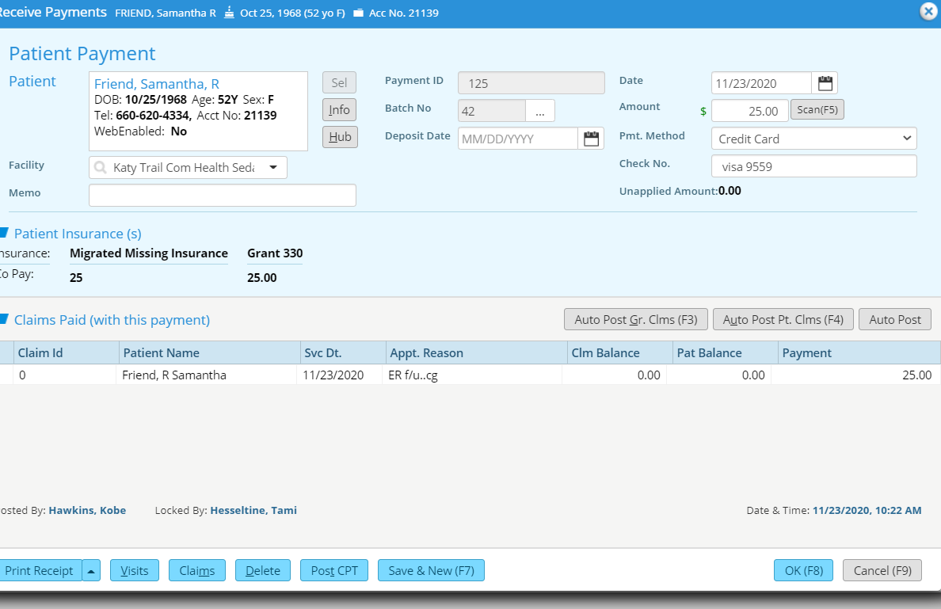
Go back to the print receipt and lock the payment.

