Ordering
Labs can be ordered for the current visit or future visits within the progress note. This can be done through the treatment window (shown below) or through an orderset or CDSS alert within the right chart panel.
- Select Treatment on the progress note & then Labs or Diagnostic Imaging in the treatment window.
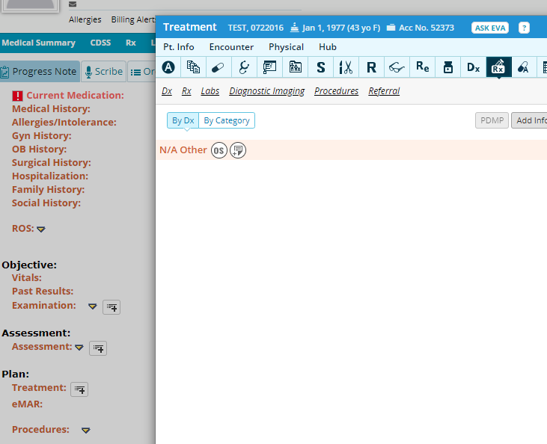
- Within the lab order window, you will enter the order.
  - Select the diagnoses (Must be done first)
  - Select the Today’s Order or Future Orders option
  - Search & select the lab test
- To make the search process easier, change your Filter By option to Contains and utilize the Type option to show IH vs Send out or both.
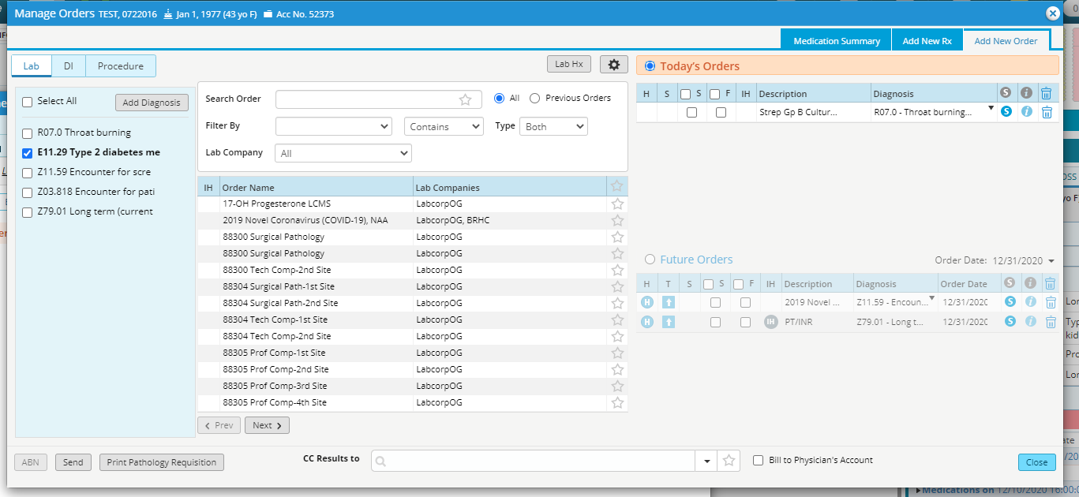
Selected lab will show as ordered.
Search for the lab & click once on lab name to select.
Select “Today’s Order” or “Future Order”
Select Dx or “add Diagnosis” to enter

- Diagnostic orders are entered the same way, by selecting the DI tab instead of Lab or toggling back and forth
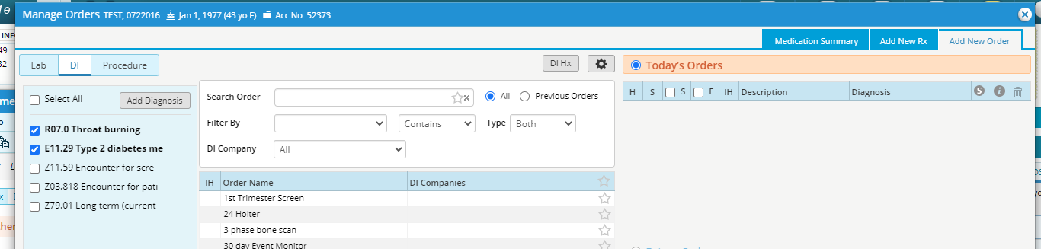

- Once all orders are entered, they will show within the Treatment window under each diagnosis
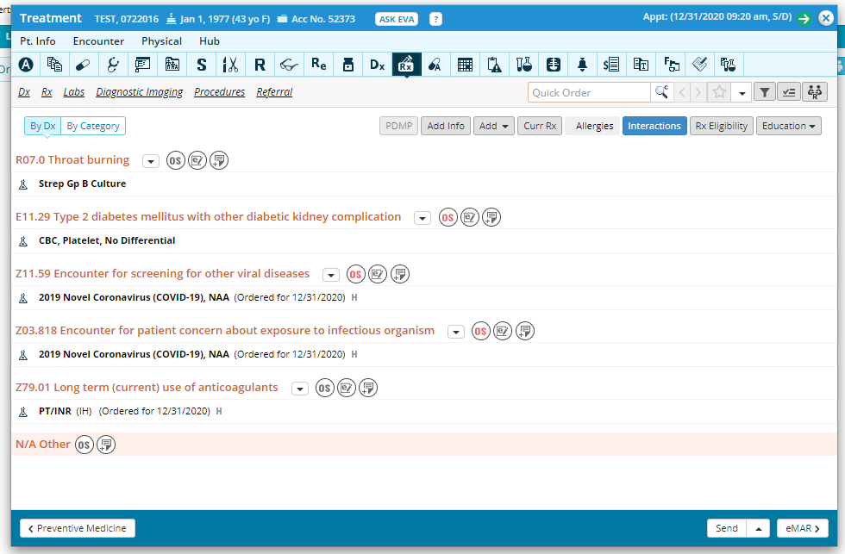

Lab Processing-
- DI- all except XRays will be processed through the referral department. You will not need to do anything with these. See below for printing Xray Orders
- In House (IH) Labs-
  - In House labs will show a pencil icon next to the name. Select this icon
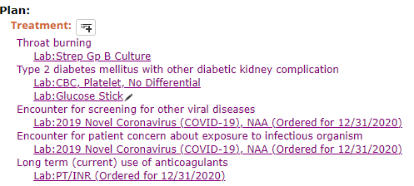

  - On the result entry window, enter the result. Select Coll. Date & select Received.
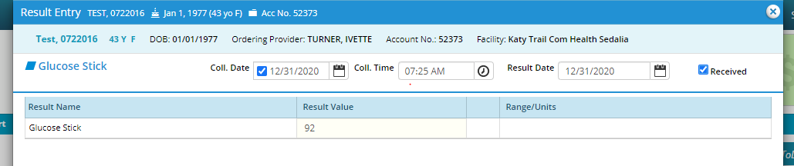

  - Select the lab order name & change the status to reviewed.

- Send Out Labs-
  - On the treatment window or progress note, select Send.
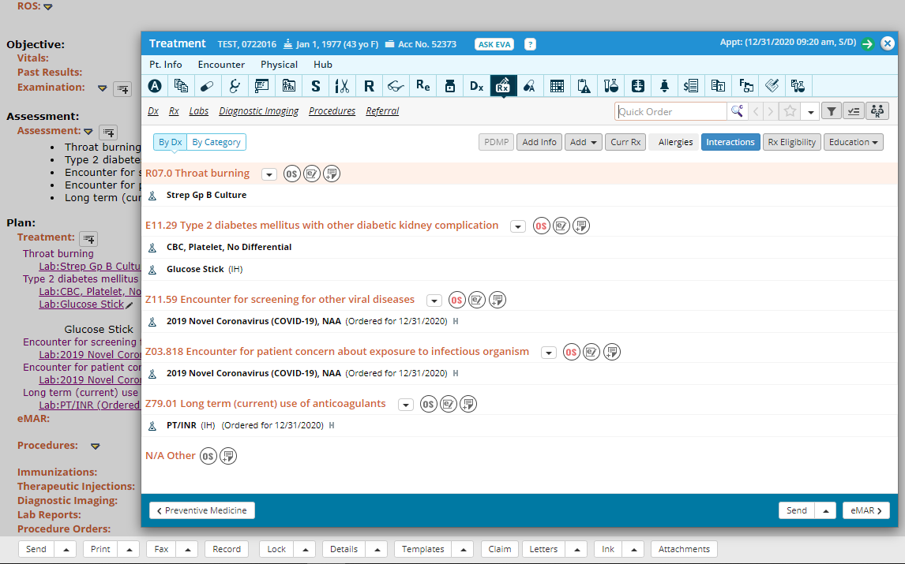

  - On the common send window, sent out labs will be selected but all labs will show. Make sure the mode states “eTransmit”.
    - Select or verify the Lab company
    - Select the Collection date if collected at clinic
    - Select SP for Labcorp send out
    - Select Print Label for Labcorp send out
    - Select Apply to selected
