If Migrated Insurance appears in Patient Information Window

1. Highlight the line
2. REMOVE by clicking on trashcan on far right

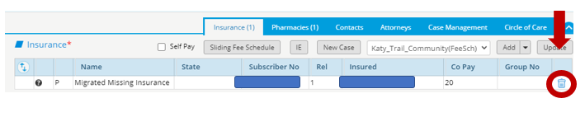

**To Verify / Update Insurance:**

* 1. Highlight insurance line and Click Update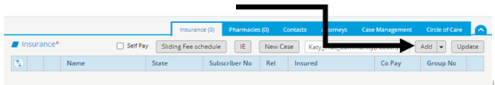
  2. Verify:

1. Insurance Name
2. Payor Order: Primary, Secondary, Tertiary – if required

*(Do not select for Insurances associated with a case)*

1. Sub No – Subscriber Number, Member ID – **NO PUNCTUATION**
2. Group No – **NO PUNCTUATION**
3. Copay Amount (Only populate for Primary Payor)
4. Patient Relationship to Insured – 1 Self
5. Click OK
6. Repeat process to verify additional active insurances

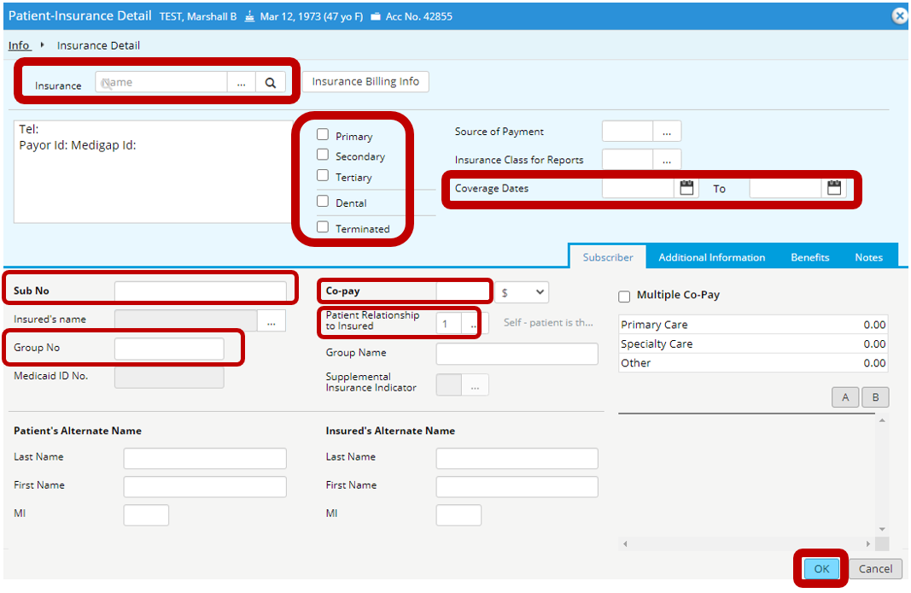

**If insurance is no longer active**

1. Highlight insurance line and Click Update
2. Check Terminated Box
3. Enter Termination Date
4. Click OK

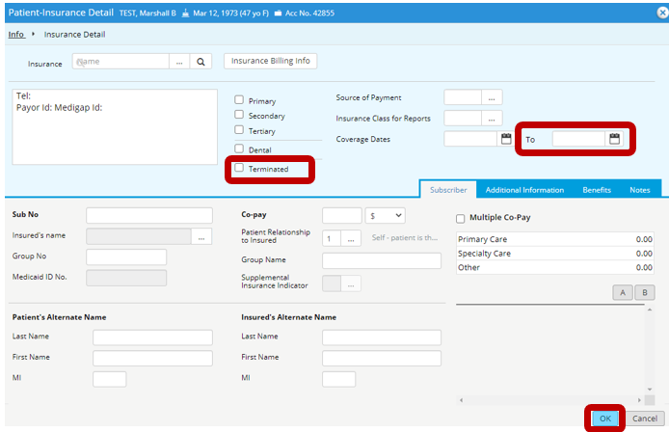

**To Add Insurance when presented with Insurance Card and you have access to eCW scanner:**

1. Click drop down caret beside Add:

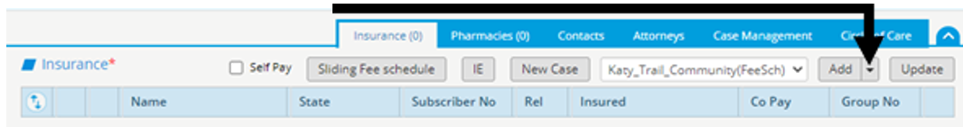

1. Place insurance card in scanner face down



1. Click Insurance Scan
2. A window will display indicating to please wait while it is fetching data
3. After card scans, this window will display
4. Click the refresh icon
5. You may receive this message window – usually you can click Refresh and the information will populate. You may have to rescan.
6. Verify correct Insurance is selected or select correct plan when prompted
7. Verify / Update **Payor Order**: Primary, Secondary, Tertiary – if required
8. Verify / Update **Sub No** – Subscriber Number, Member ID **– NO PUNCTUATION**
9. Verify / Update **Group No** **– NO PUNCTUATION**
10. Verify / Update Copay Amount (Only populate for Primary Payor)
11. Patient Relationship to Insured – 1 Self
12. Click OK



A copy of insurance card is available in Patient Documents.

Repeat process for each active insurance.

Follow above process to add card scan to existing insurance plans as well.

**To Add Insurance without Insurance Card Scan:**

1. Click Add:

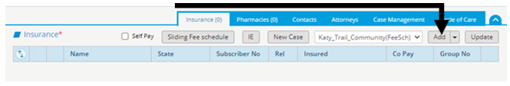

1. Search for & Select Applicable Insurance
2. Set Payor Order: Primary, Secondary, Tertiary – if required

*(Do not select for Insurances associated with a case)*

1. Sub No – Subscriber Number, Member ID **– NO PUNCTUATION**
2. Group No **– NO PUNCTUATION**
3. Copay Amount (Only populate for Primary Payor)
4. Patient Relationship to Insured – 1 Self
5. Click OK



Repeat process for each active insurance

**Add Grant Type (SMHW, Title X, Boys & Girls Club, Pathways)**

**and Behavioral Health Insurances**

Follow above process, but do not select payor order

**CREATE CASE when applicable**

*Verify insurance has been added as an insurance and Payor order has been left blank*

1. Select New Case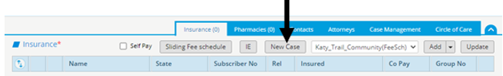
2. Click  and Select Case Type
3. Enter Case Label with start date of case using date format of: **yyyy.mm.dd**
4. Click Add Ins
5. Select insurance to be associated with case
6. Click OK

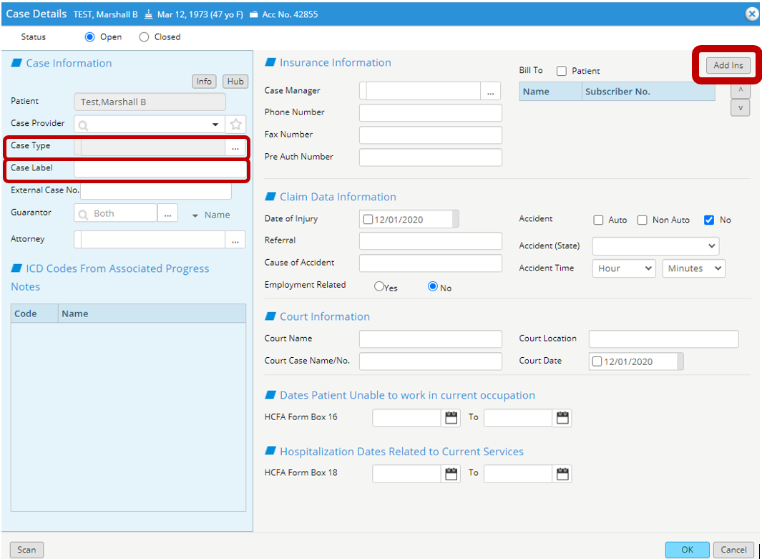

**SLIDING FEE SCALE and INCOME DOCUMENTATION**

Income information must be recorded for all patients both for Sliding Fee Scale information and as Income Documentation even if not participating in SFS

1. Click Sliding Fee Schedule

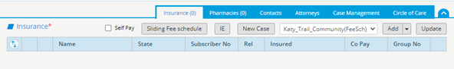

1. Enter Gross Income
2. Select Gross Income Pay Period
3. Enter Total Number of Qualifying Members in Household
4. Press Calculate

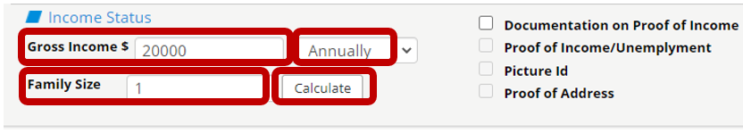

* + - * 1. If patient does not qualify, this message box will appear



i. Click OK

ii. Check Non Proof of Income box at top left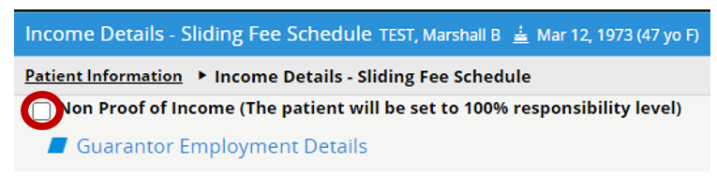

iii. Click Assign at bottom right



iv. Click Close at bottom right

b. If patient qualifies, but does not wish to participate in SFS

1. Check Non Proof of Income box at top left 
2. Click Assign at bottom right



1. Click Close at bottom right

c. If patient qualifies for SFS Grant and wishes to participate

1. Check 
2. Confirm Status updates to **Assigned**
3. Update Copay Resp to applicable copay amount
4. Verify / Update Date fields

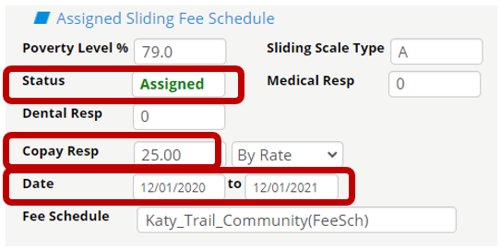

1. Click Assign



1. Click Close at bottom right

**For those patients participating in Sliding Fee Grant Program,**

**add Grant 330 Insurance as Payor.**

* 1. Follow Steps above on Adding Insurance
  2. Select Grant 330 as Insurance
  3. Set Payor Order: Primary, Secondary, Tertiary
  4. Enter Coverage Dates
  5. Sub No: Enter Level determined in previous calculation step
  6. Copay: Populate with applicable copay for level
  7. Set Patient Relationship to Insured – 1 Self
  8. Click OK

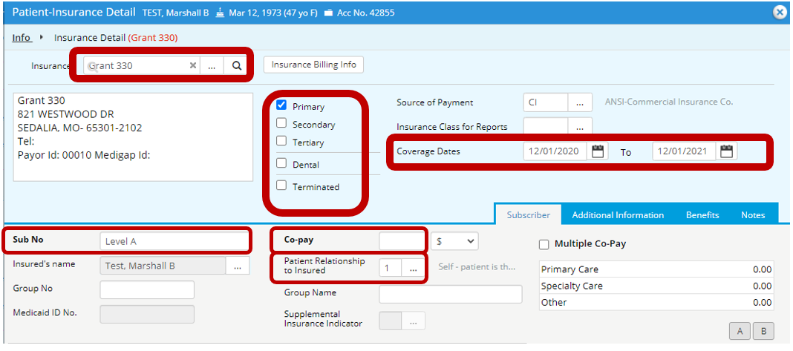

If patient is approved for temporary grant, use Coverage Dates, populate with current date as start date and end date as 15 days from current date. If patient does not bring income documentation within the 15 days, the temporary grant will expire.

**If patient is self pay and does not qualify for or declines to participate in Sliding Fee Grant, add Patient Responsibility as Payor.**

1. Follow Steps above on Adding Insurance
2. Select Patient Responsibility as Insurance
3. Set Payor Order: Primary
4. Enter Coverage Begin Date
5. Set Patient Relationship to Insured – 1 Self
6. Click OK 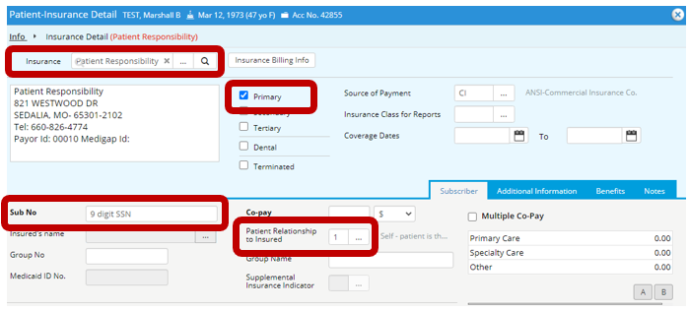

Window Returns to Patient Information Window

1. Check Self Pay box