1. Click Documents on the left side of screen.

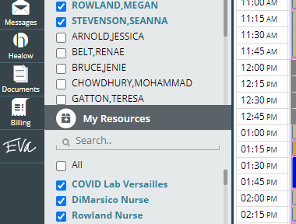

2. Select Documents

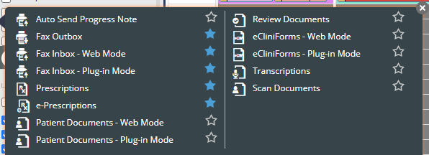

3. make sure all your setting on left hand side is set for scanning documents. eCW university suggest to set your DPI (dots per inch) at 300 for best quality. You will have to separate out your one-sided documents from your double-sided documents. When you scan the double-sided documents make sure to select Duplex. you can create two separate profiles to not have to change this each time.

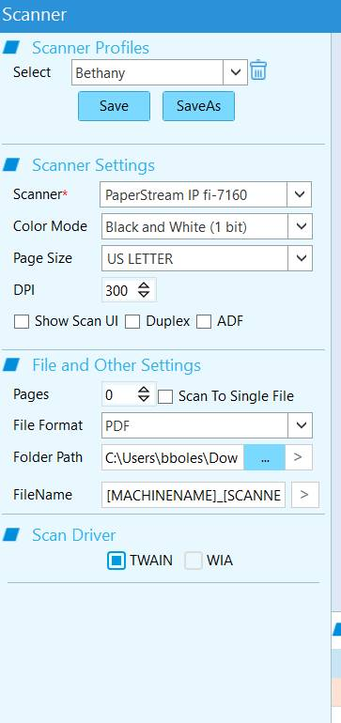

To set scanner profile

\* clear out where it says select

\* set your settings below to what you would like them to be then click save as.

I suggest doing one for normal scanning then setting one with duplex and labeling it double sided.



4.place all documents in the scanner, select scan in the bottom right corner

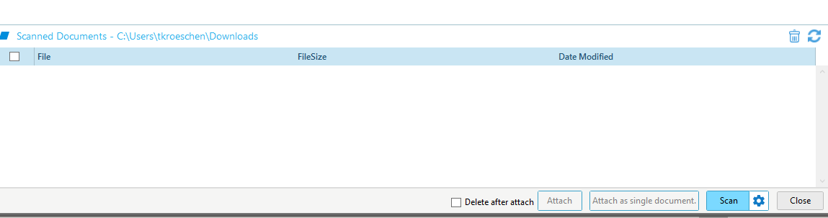



5. documents will all show, select the document you want to assign to a chart. Click attach at the bottom right side of screen.

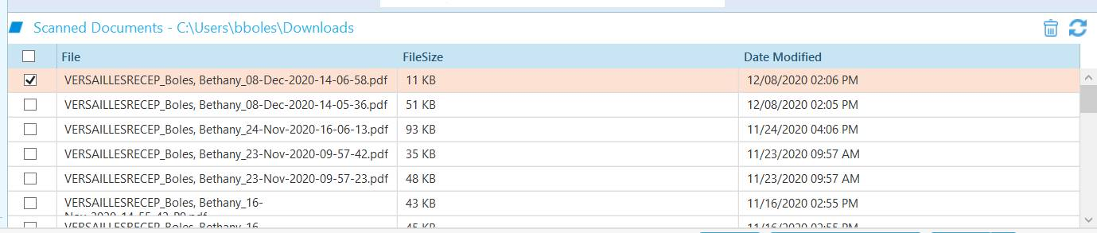6. place patient name in patient lookup screen

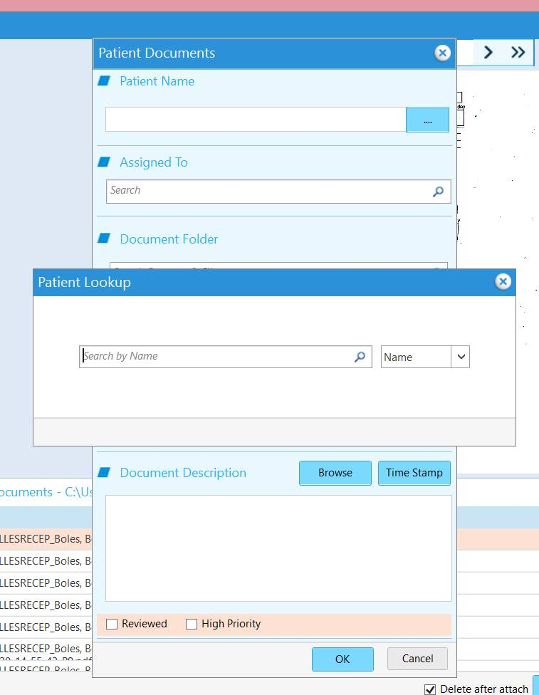

7. if document needs to be assigned, assign here. Choose the folder you would like the document to go into. Change the Document name to (year, month, day, name of document) select okay

