- Open Hub
- Select dropdown arrow next to Account Inquiry Add Patient Payment
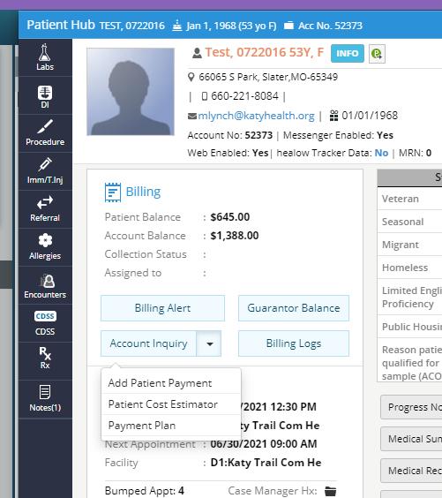
- Enter the required payment information:
  - Amount
  - Pmt Method
  - Check No.
    - Last four of credit card & card type (i.e. 9123 VISA), or
    - Entire check number & company (i.e. 0023 Central Bank)
  - Memo
    - If balance is from IMS, notate this on memo & skip to step 7 below.
    - If balance is for an upcoming service not yet rendered, skip to step 7 below.
    - If balance is from eCW, notate Balance payment and statement date, if known. Continue all steps below.
- Select the Claims option
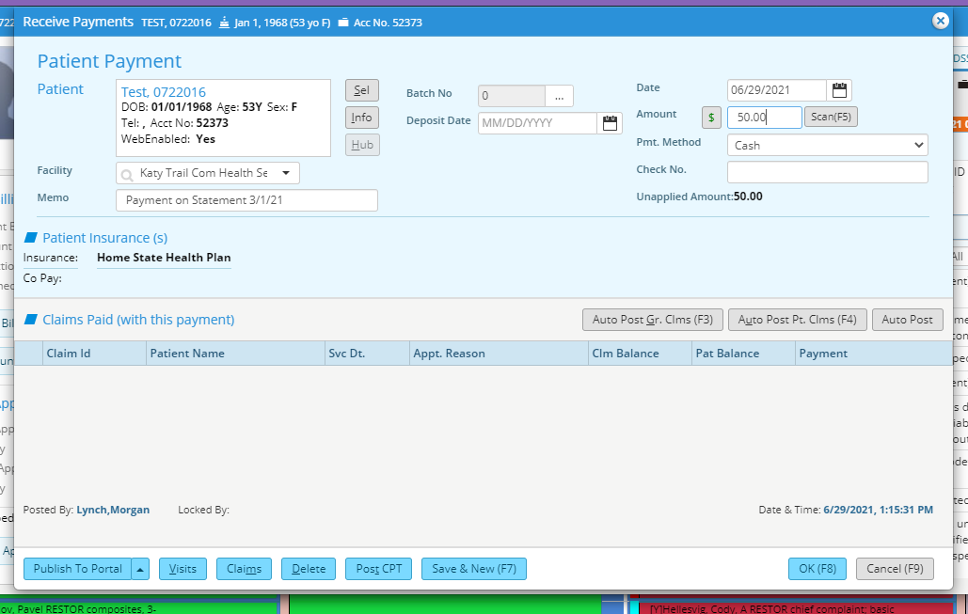
- Select the DOS on the statement Select OK
  - If pt is unsure of DOS and doesn’t have statement, select oldest balance
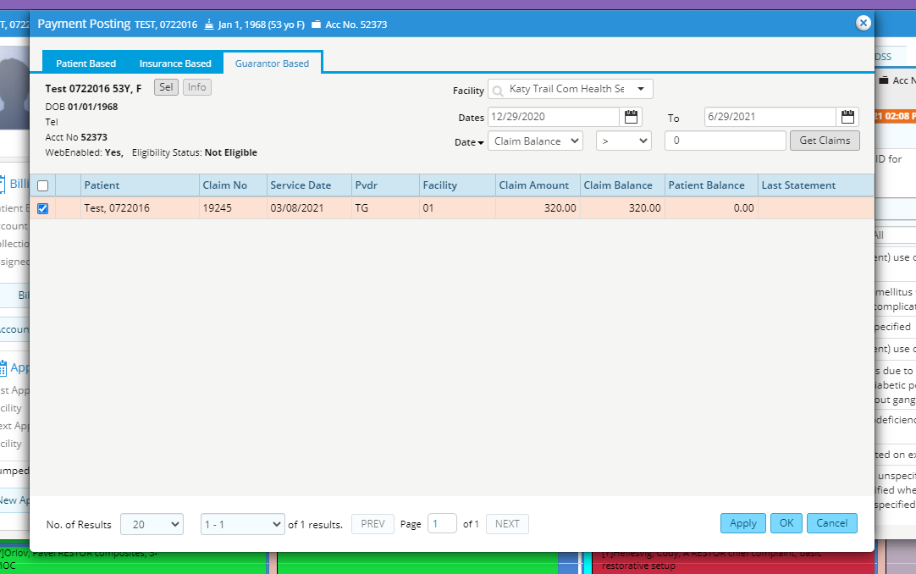
- Select Auto Post and validate that the patient balance changes to cover the amount paid
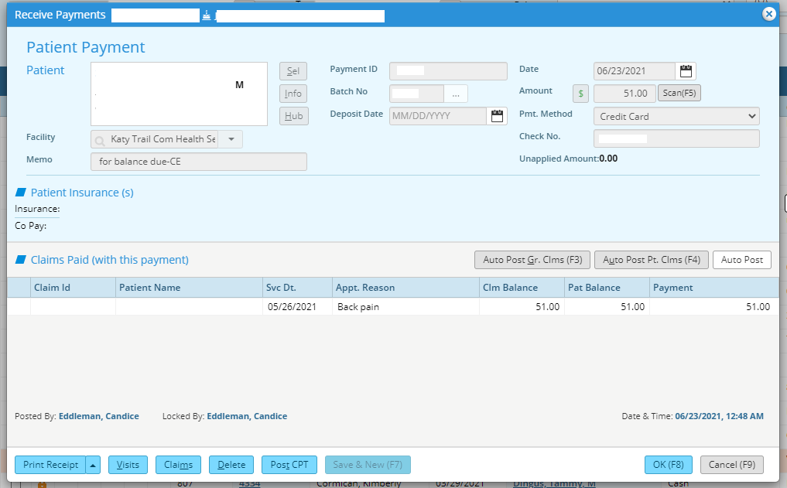
- Print two receipts, one for the patient & one for KTCH receipts.
- Select “OK” to save.
- You may receive an error regarding the service & payment dates being different. Select “OK” to continue and save.
