- Create Telephone Encounter
- Fill in: caller, reason, provider
- Messages: Received _______ medication through PAPRX.

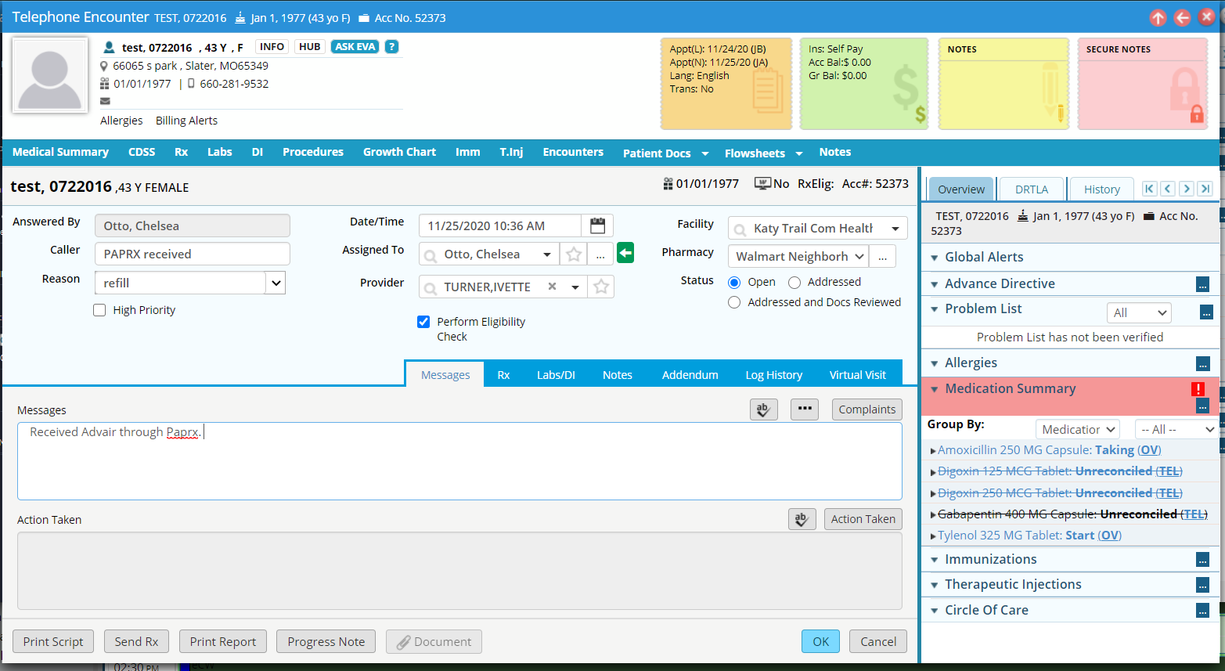

- Select Current Rx

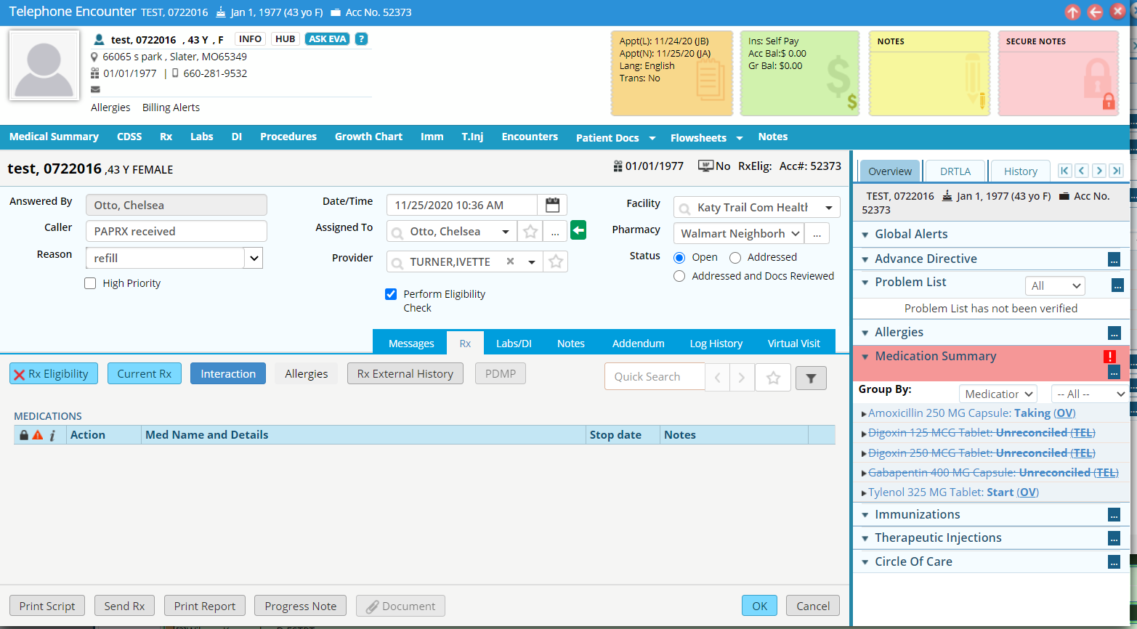
- If the medication is not on the current list add New Rx
- For the correct medication click the “C” circle for continue
- Click ok
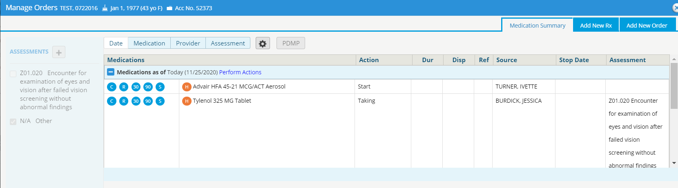
- Back on the telephone encounter click on the medication.
- In the note section add: LOT, EXP, and amount received
- Click ok
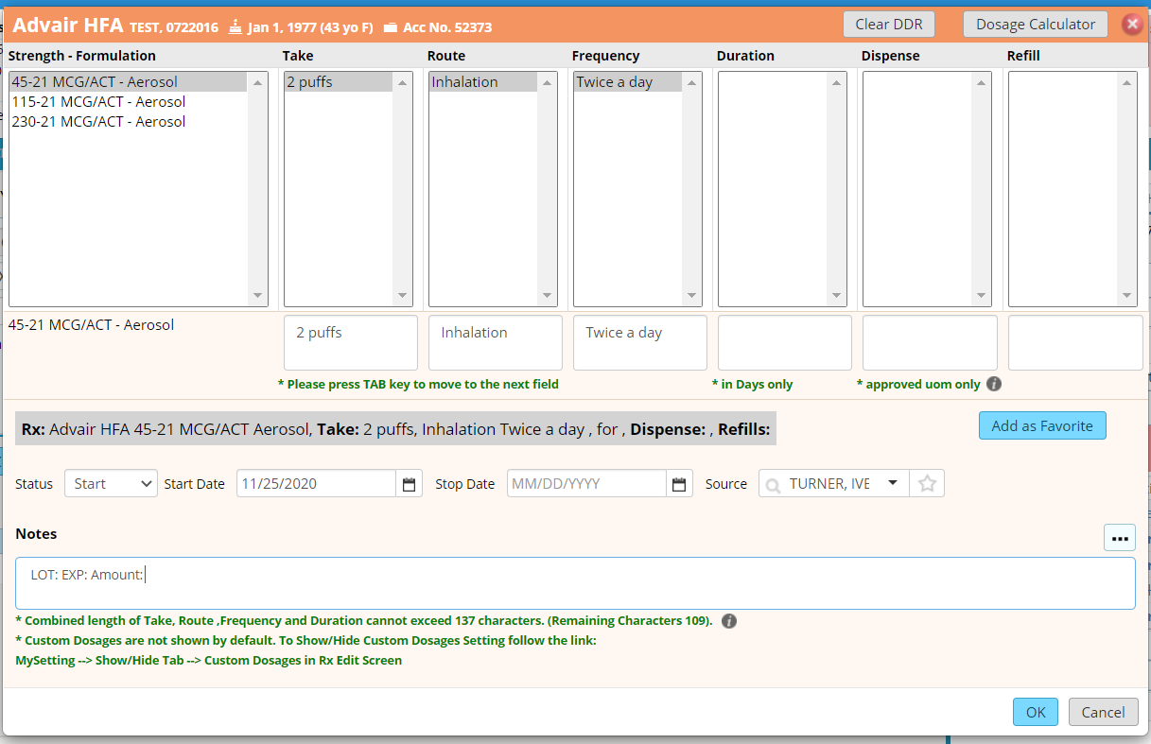

- Back on the telephone encounter under action taken document medication was received and documentation of contacting the patient.
