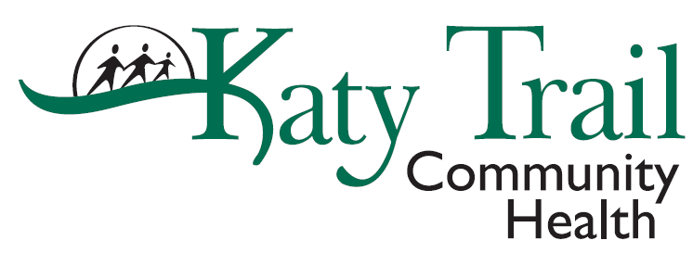

MEMORANDUM
To: All Employees
From: Tina Fisher, HR Director

Date: January 11, 2022
RE: Omicron Variant and COVID-19 Pay
Your health and safety are a top priority. We have assessed the current surge with Omicron variant and will be implementing five (5) days company paid COVID pay through March 18, 2022 for positive results that require an employee to isolate, regardless of vaccination status We will retro COVID pay back to Jan 3, 2022. If you were in isolation during that period, please reach out to Tina Fisher, HR Director, for more information.
In addition, we would like to remind staff of incentives that are available to staff:
- $2/hour differential for non-clinical staff who are licensed/certified that are deployed to perform clinical duties
- $2/hour differential for non-provider clinical staff who are deployed to provide COVID-19 clinic and community services
- Hourly staff who are deployed to another clinic due to staffing shortages are eligible for $25/day. For the $25/day staffing travel reimbursement, you must complete the Expense Reimbursement Travel Form and submit with your manager’s signature. On the first page of the form, indicate Staffing Travel and the clinic you traveled to. This $25/day is in addition to the mileage you may be eligible to claim. The form is located on The Trail (Forms > Payroll and Finance).
These incentives and COVID-19 Pay are temporary as we will continue to monitor the pandemic and adjust as needed based on COVID-19 surges.
We know the pandemic has been a rather unusual stressful and challenging time. Loyal and dedicated employees like you are the foundation to any successful company. Thank you for your contribution to our success! Throughout this time it's important that we support each other and the community. We're all in this together.

