Referrals for internal and external services will be entered as outgoing referrals

Internal Services will be entered within an outgoing referral. Utilize the below Specialty options:
Dietician Services- Dietician Behavioral Health (Mental)- Behavioral Health Specialist
Psychiatry Services- Psychiatry Behavioral Health (Chronic Dx)- Chronic Disease Management
Dental Services- Dental Care Medical Services (from dental)- Primary Care
IBHS- IBHS Case Management- Case Management
Care Coordination- Care Coordination Medicaid Initiative/PCHH- Primary Care Health Home (PCHH)

Referrals can be entered through the patient hub, progress note or the R Jelly Bean.
Entering from the patient hub:
- Using the patient look up, within the patient’s hub select referral on the left side panel
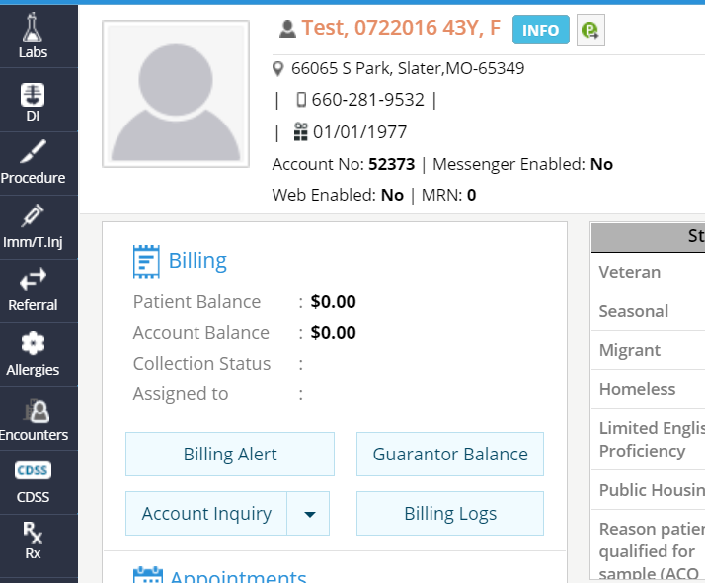

Toggle over to outgoing referrals and then select new
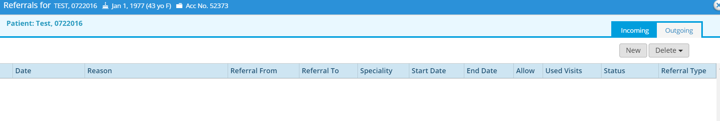
- Follow steps for completing referral below.

Entering from the progress note:
- Use the treatment window within the progress note to enter the referral
  - Select Treatment>Referral
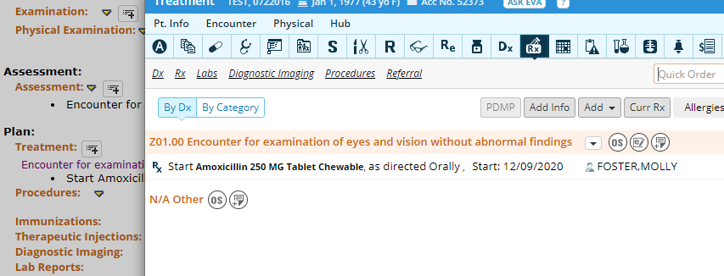
- The (outgoing) referral window will open. All items with * must be completed
- From Provider- if referred from progress note, this will auto populate
- Specialty
- Reason-this information should support the diagnosis
- Diagnosis
- Assigned To* this will auto-populate when you select the (From Provider), if it does not auto populate, search and select Ashley Vajen.

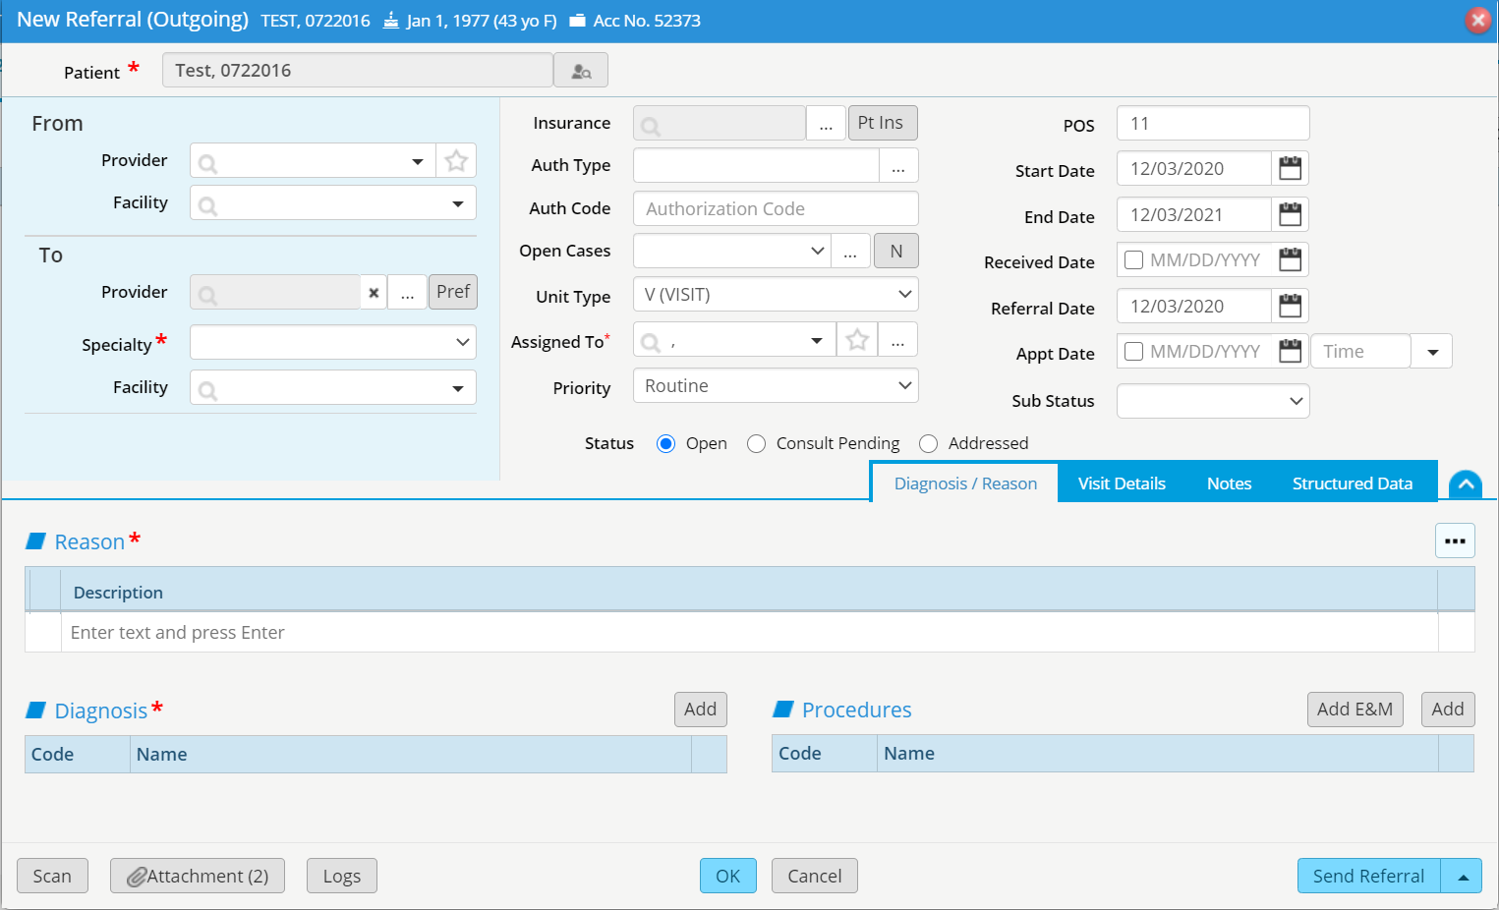

Diagnosis should match visit note diagnosis code
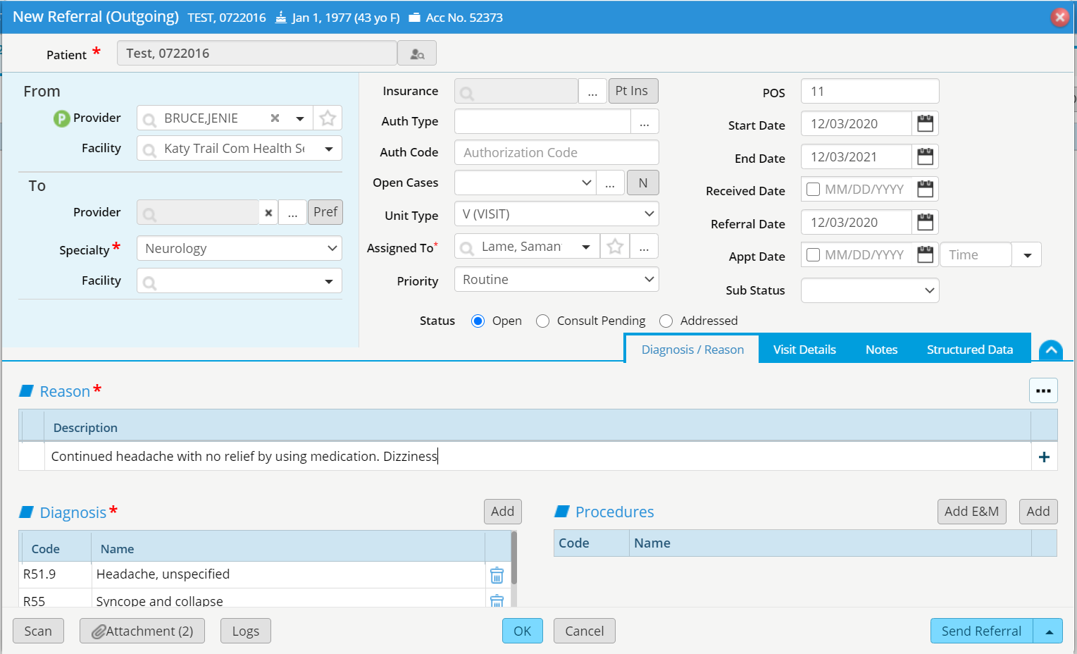
Specialty must be selected
Reason should support diagnosis documented
- Note section: please use this section to state where the patient would like to be sent and any other helpful information
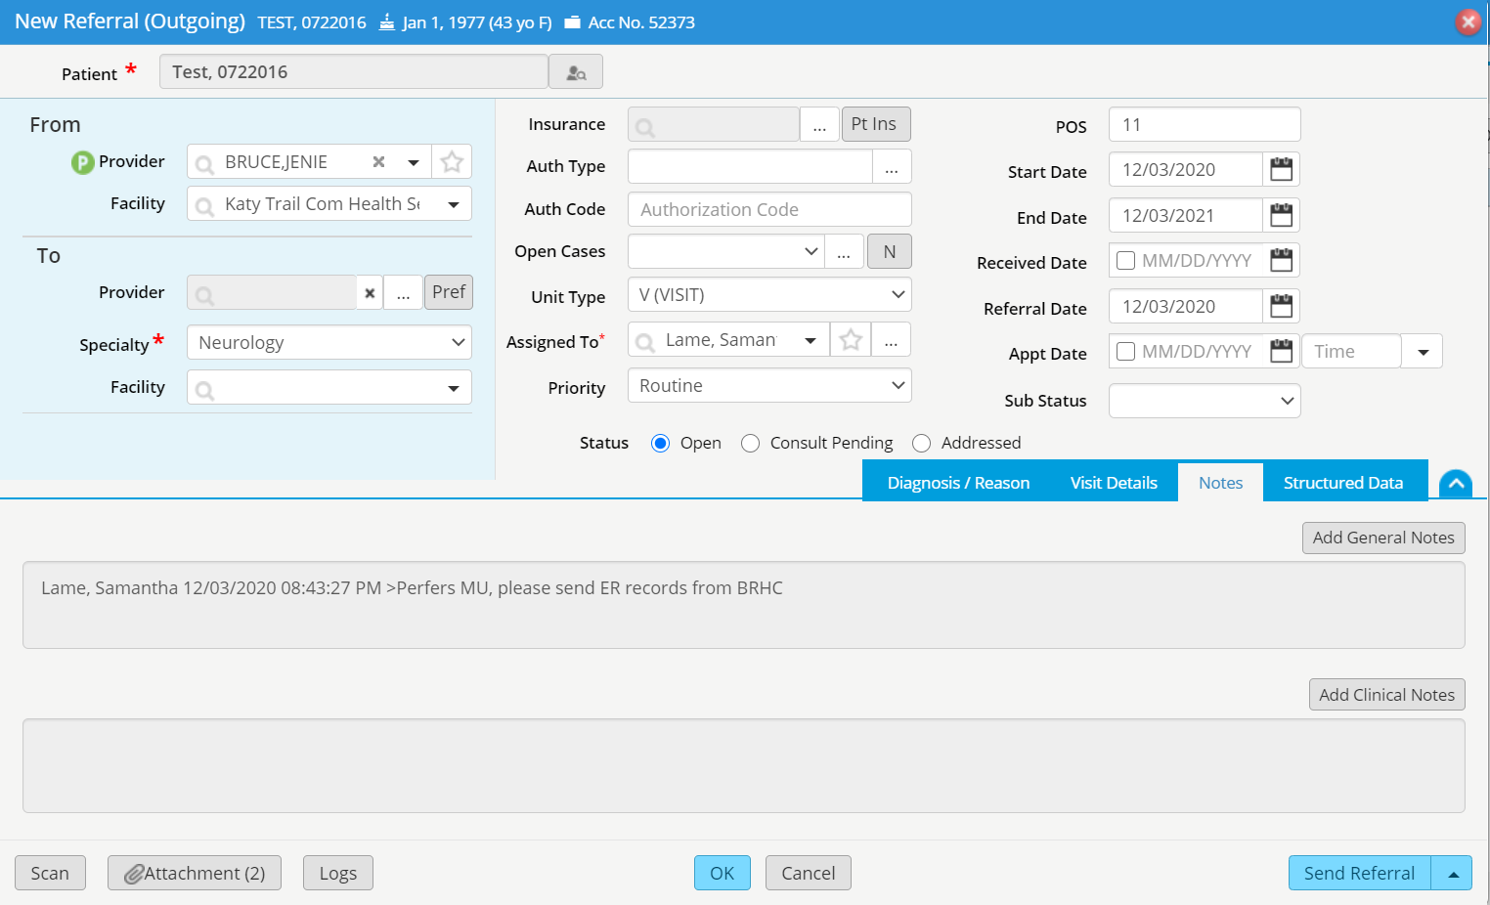

- Select OK once the referral information is complete
